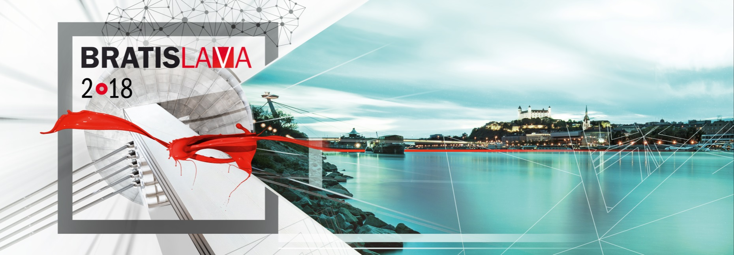

PRESS RELEASE

Baumit selects the European Façade of the Year 2018 in Bratislava

36 finalists from 26 Baumit countries attended the Grand Final, which took place on 14 June at the Slovak Philharmonic in Bratislava. An international jury of leading architects selected the six category winners and the overall winner of the Baumit Life Challenge. As in 2014, Spain won the top prize “Life Challenge Award 2018” again.

Bratislava/Wopfing, June 2018 – On Thursday, 14 June 2018 at the Slovak Philharmonic, Baumit presented the Baumit Life Challenge Award for the European Façade of the Year. In their final jury session, 13 highly respected architects selected the winners in the single-family house, multi-family residential, non-residential building, thermal renovation and historic renovation categories, as well as the special category, "Stunned by Texture".

The Spanish project, "COLLECTIVE HOUSING AND HEALTH CENTRE", from the architectural team of Bonell i Gil & Peris + Toral was selected as the overall winner of the Baumit Life Challenge 2018.
Three other countries had reason to be cheerful: Slovenia – with even 2 category wins - as well as Czech Republik, Germany and Austria with each one category prize. Spain also celebrated another victory, winning the award for the "Thermal Renovation" category.

"In 2014, we opened the Baumit Life Challenge to entrants from all over Europe for the first time, in order to showcase the countless creative possibilities for designing façade surfaces and structures. The growing international interest in this award shown by architects, investors and contractors - we received 325 entries this year - inspired us to hold the Baumit Life Challenge every two years," said Robert Schmid, CEO of Baumit Beteiligungen GmbH, as he hailed a splendid evening "in which Europe's construction industry celebrated the winners in the manner that they deserved".

European Façade of the Year 2018: An overview of the winning projects

Overall winner: "COLLECTIVE HOUSING AND HEALTH CENTRE", Spain
http://lifechallenge.baumit.com/project/394

The six category winners:

Single-family house "PAVILION IN A HAYRACK", Slovenia
http://lifechallenge.baumit.com/project/433

Multi-family residential "BEAUTIFUL ELDERLY LIFE", Slovenia http://lifechallenge.baumit.com/project/431

Non-residential building "STUDENT CLUB - SOUTH BOHEMIA", Czech Republic http://lifechallenge.baumit.com/project/515

Historical renovation "PAULANER BREWERY", Germany
http://lifechallenge.baumit.com/project/288

Thermal renovation "TORRE 30. MADRID", Spain
http://lifechallenge.baumit.com/project/274

Special category, "Stunned by Texture" "HOUSE MARIE", Austria http://lifechallenge.baumit.com/project/45

Five categories, one special prize
The motto of Life Challenge 2018 was "Stunned by Texture". This year, as well as the categories of Single Family House, Apartment Building and Non-Residential, and the two categories of Thermal Refurbishment and Historic Renovation, there was a special prize for buildings with an exceptional façade structure. Each of the six category winners received EUR 6,660 in prize money. The overall winner was awarded EUR 9,900. These sums are not chosen randomly, as 66 percent of each façade can be fashioned using Baumit products.

About Baumit
Baumit International was founded in 1988 and is now an established force in the European construction materials industry. Baumit is a market-leading producer of external thermal insulation composite systems (ETICS) and final coatings for façades in Central Europe. It produces more than 40 million square metres of thermal insulation every year - a good reason to trust in Baumit's high-quality and versatile insulation products. The Baumit group has facilities and subsidiaries in 26 European countries and in the People's Republic of China. Baumit has 3,350 employees and expects to achieve turnover in excess of EUR 1 billion in 2018.

Please find attached a photo of the award ceremony in JPG format.
Baumit_Life_Challenge_Award_2018_Winner.jpg
Caption: Robert Schmid, CEO of Baumit Beteiligungen GmbH and instigator of the Europe-wide competition, enjoys a splendid evening at the Slovak Philharmonic with Baumit International Director Alfred Gsandtner, Baumit Spain CEO Fernando Arrabé Gomez, and the overall winners of the Baumit Life Challenge 2018, the architectural team of Bonell i Gil & Peris + Toral.
From left: Robert Schmid, presenter Vera Wister, Marta Peris and José Manuel Toral (the architectural firm Bonell i Gil & Peris + Toral), Alfred Gsandtner and Fernando Arrabé Gomez.

Photo credits: Dimova Yuliya /Baumit

Furter information is available from:
lifechallenge.baumit.com
www.baumit.com

Press contact:

Baumit Beteiligungen GmbH
Elisabeth Fürst
2754 Wopfing 156
Austria

Tel. +43 (0) 501 888 – 1117
mailto:e.fuerst@baumit.com

